CSDA1020
Big Data Analytics Tools
Project 1, Hadoop and Hive Project

S.E.A.L. Cars
Analysis Report

Created: Susiette Adams
Table of Contents
- Introduction 2
- Data being prepared to be loaded into Hive 2
- Creat project1 database then a cartabled to load car.csv data 2
- Loading the car.csv data into “cartable” and confirm its first 5 rows of the data 3
Analysis (Questions) 3
- Identifying cars that has the most value 3
6. Loading in the value to newly created “average” table, and diplay the first 5 entries 4
7.Top 10 makers with highest avg. mileage 4
8.Top 10 makes with highest ave.price 5
9. Sort the economy cars group 5
10. Sort the luxury cars group 6
11. Quality of data impacting the quality of this analysis 6
12. Broaden the search to top 20 highest avg. Mileage 6
13. Our 5 recommendations 7
14. Analyzing the data by fuel type 7
15. Adding the data into the new table “fuel” 7
16. Reesults from the fuel table query 8
17. Is there a relationship beteen make, model and price? 8
18. Cleaning the data 8
19. Does Fuel Type have an impact on price? 9
20. Conclusion 9

- Introduction
The cars data that is used for our analysis was put together from several different websites. In Czech Republic and Germany over a period of more than a year. Some of the sources provided unstructured data, so as a result the data is dirty. There are missing values and some values are very wrong. For example phone numbers have been inputed as mileage in some cases. The data is consist of roughly 3.5 Million rows and sixteen columns: maker, model, mileage - in KM, manufacture_year, engine_displacement, engine_power, body_type, color_slug, stk_year, transmission, door_count, seat_count, fuel_type, date_created, date_last_seen, price_eur.

We will be focusing on the make, milgage,fuel type and price to estimate which cars have the best resale value.These factors will help us come to a decision to consider only economical cars or both luxury and economical cars for our business to specialize in. We will be using Hadoop and Hive in Google Cload Platform to perform our analysis.

- The car data was previously uploaded into hadoop and the database was previosly craeted below shows the data being prepared to be loaded into Hive.



- Here we have “project1” database in Hive then a table named “cartable” to load car.csv data in.



- Loading the car.csv data into “cartable” and confirm its first 5 rows of the data.

Analysis (Questions)
1. What is the relationship between car makes, models and price?
2. What are the top five vehicle manufacturers would you recommend? Why?
3. Does fuel type have any impact on the car price? Explain

- Although these are specific questions, our analysis is to identify cars that has the most value. We have decided to run numerous queries to find out what can be indicators of good value in cars.

We first tried to identify car makers with the highest avg. mileage (lifespan) and highest avg. resale price. In order to get the results we created a new table to store the avg. mileage and avg. price by maker in.

- From the car.csv data we are loading in the value to newly created “average” table, and diplay the first entries.

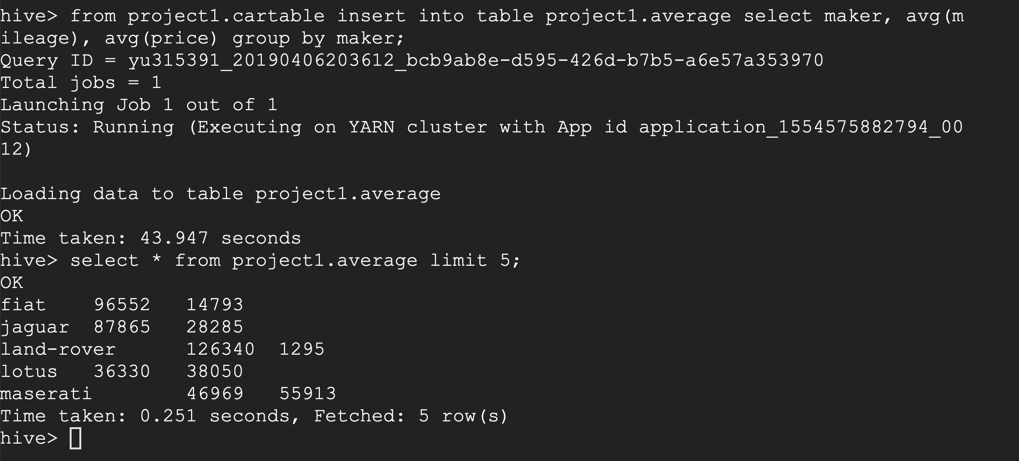

From the results above the Jaguar, Lotus and the Maserati seem to have the best results out of the 5 outputs when comparing the milage and the price.

- Here are top 10 makers with highest avg. mileage. Although there are other factors to be considered, this can be an indicator of avg. lifespan of vehicle.

If we are looking at the lifespan of the cars from the outputs above Chrysler seem to have the best lifespan. The life span of the cars would also depend on how well the owners maintained the cars.

- Here are the top 10 makers with highest avg. price. This can be an indication of good resale value of a car.

Unfortunately, highest avg. price itself does not seem like a good indication of car value because this list mostly consists of high-end luxury vehicle. Obviously, luxury vehicle’s price is higher than economy cars. As stated in the introduction the data quality is poor.Therefore, we have decided to analyze cars in economy group (top 10 highest avg. mileage) and luxury group (top 10 highest avg. price).

- In order to come up with more reasonable numbers, we will sort the economy cars group by highest avg. mileage then also including their avg. prices to view their avg. resale value as well.

Keep in mind the quality of the dataset is impacting the results of the analysis. For instance, Subaru’s avg. mileage(136K) has placed it in economy group but its avg. price (147K) which does not seem realistic. In addition, rows are missing “maker” field got included in this group, which averaged 547K in price and 124K in mileage. Despite the fact, this analysis is suggesting some good economic options such as Chrysler, Skoda, Volvo, Honda, Ford, and Volkswagen. And some options with realy bad resale value such as Alfa-Romeo and Land-Rover.
- Now we perform the same analysis on luxury group. In order to do that, we sort the group by highest avg. price then also including their avg. mileage to review how much they are driven.

- Again, we see that quality of data is impacting the quality of this analysis. For instance, prices for Renault, BMW, Subaru(again), Citroen are not realistic and value with no maker field got included in this list again. However, a trend in luxury group can be seen in this analysis. High-end luxury vehicles like Lamborghini, Bentley, Porsche, Maserati are not driven more than 100K in mileage whereas top 10 in economy group are all driven more than 100K.

- After all, as we are analysing a used-car dataset, and because we are making a recommendation for the valueable vehicles we will broaden our search to top 20 highest avg. mileage.
- As we keep “Value” in my mind and long-distance driven cars while maintaining higher resale value, here are our 5 recommendations.

- Volvo
- Honda
- Land Rover
- Audi
- Mercedes-Benz or Lexus

- Now, in order to analyze the data by fuel type we have created a new table.

- We have added the data into the new table “fuel”, applying the same logic where avg. mileage and avg. price will illustrate vehicle’s value by fuel type.

- Here are the result from the fuel table query.

While Gasoline vehicles show most distance driven and highest resale value, Diesel seems to be 2nd. LPG and Electric vehicles seem to have similar efficiency. CNG has the least avg. mileage and lowest price.

- Is there a relationship beteen make, model and price?

There is definitely a relationship between the 3 variables they are all connected and can be dependant or independent variables in some cases. We would no have been able to complete our analysis without inclused one or more of these variables.

- From the analysis, it was evident that the quality of the data was impacting our analysis. Steps were taken to clean the data, but it seems as though these attempts did not work. See below where we attempted to remove all NULL values from the ‘maker’ column. By creating a temp table which was essentially a copy of the original table but with a condition applied. The original table was overwritten with the temp table (intending to account for the NULL values in ‘maker’ thereby reducing the overall number of rows). However, after checking the number of rows, it seems that this code had no effect.

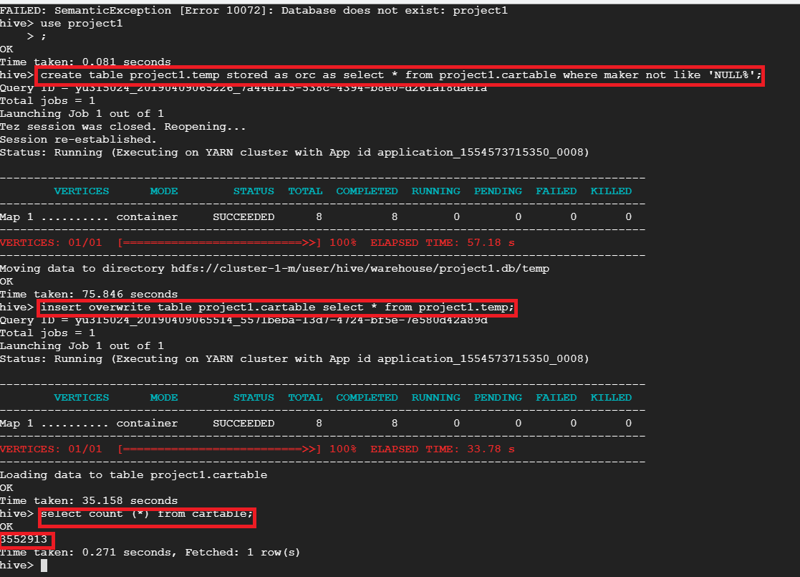

Other possible data cleansing tasks could include:

- Limiting the range of values for certain columns (Mileage, Price)
- Re-mapping ‘price’ column to be presented in CAD (vs. Euros)

- Does Fuel Type have an impact on price?

The type of fuel does seem to have an impact on the price of the car. In our analysis above gasoline cars seem to have more distance drive with the highest resale value. Disel cars are second in line with driving distance and price. If we are to compare the two gasoline/petrol is much easily to find at a gas station, and some fuel station do not carry deisel as much as gasoline. In the past disel fuel had alot of air pollution concerns than gasoline cars. In the past disel cars were seen as more fuel efficient than gasoline cars, but that has changed because gasoline cars are now built to be more fuel efficient.

- Conclusion
Afetr carefully revieving and analysing the cars dataset for the prospective used car business our advice is based on the intention to maximize revenue and profit. Revenue is dependent on car sales and sales is dependent on the value proposition for prospective customers. We have made a judgement that used car customers want reliable cars that also retain monetary value relatively longer than other alternatives. As such, the cars we are recommending are the best candidates to meet those two requirements as shown by the 'mileage' and 'price' analysis.

